**Appendix C**

**Graphical User-Interface Screenshots**

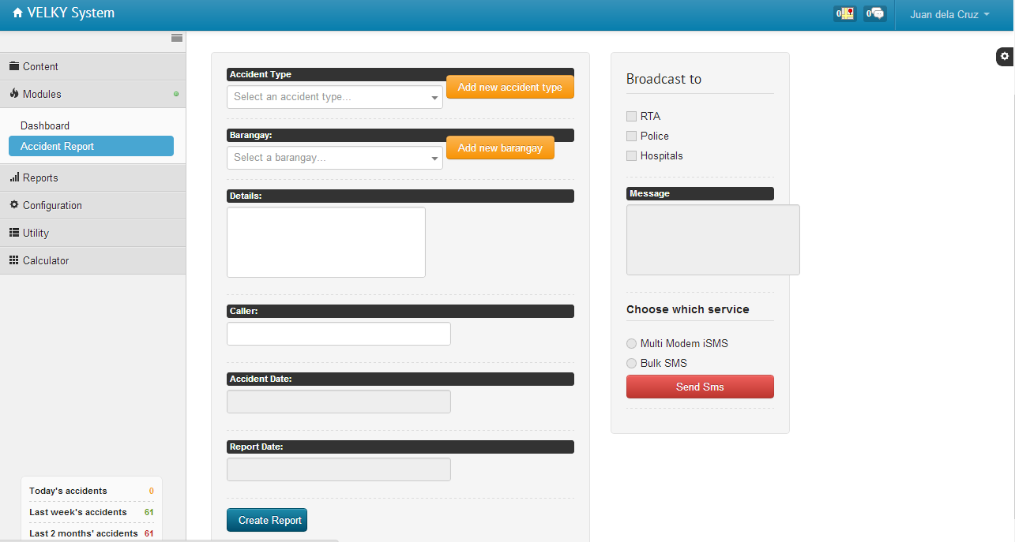

This screenshot shows Accident Report page under Modules Menu

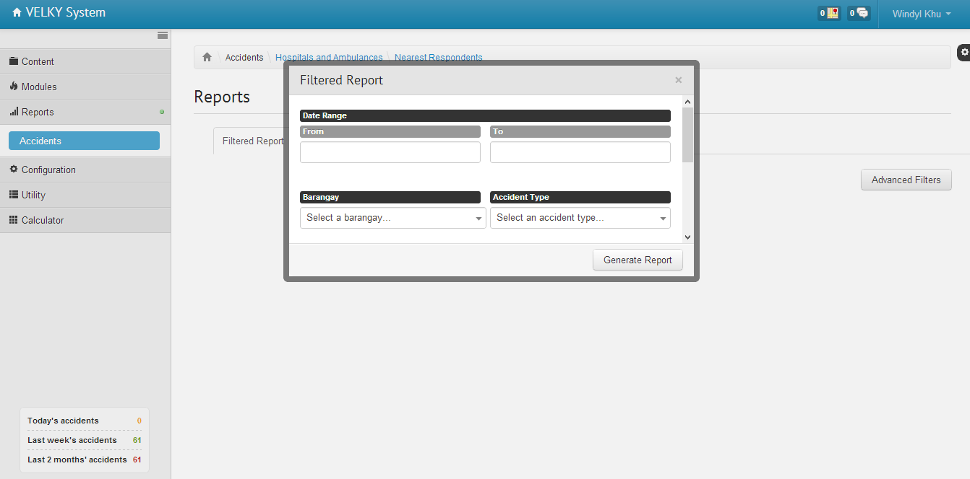

This screenshot shows the Filtered Report dialog box in Accidents category under Reports menu.

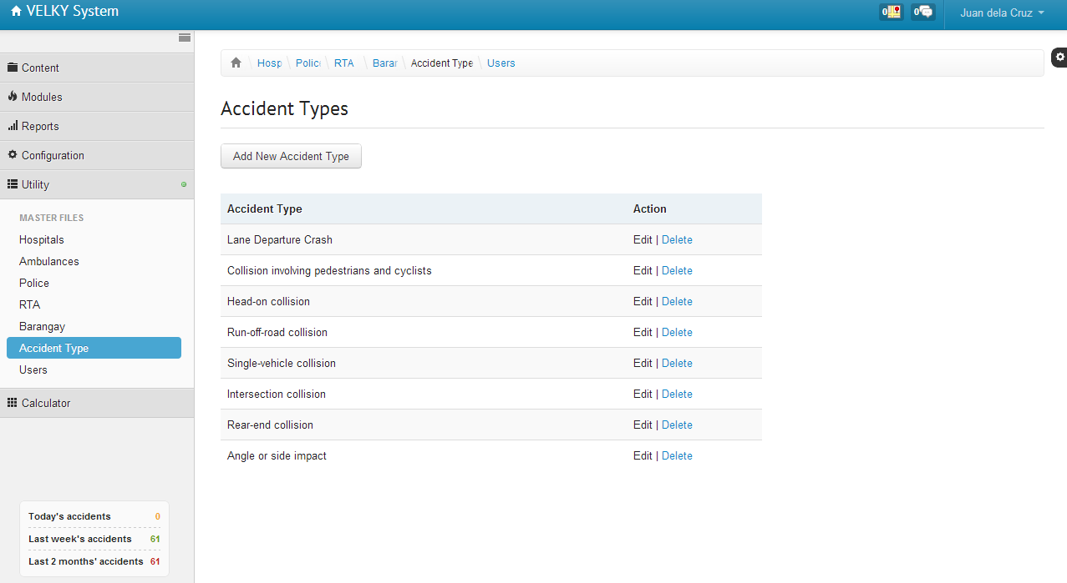

This screenshot shows Accident Types master file under Utility menu

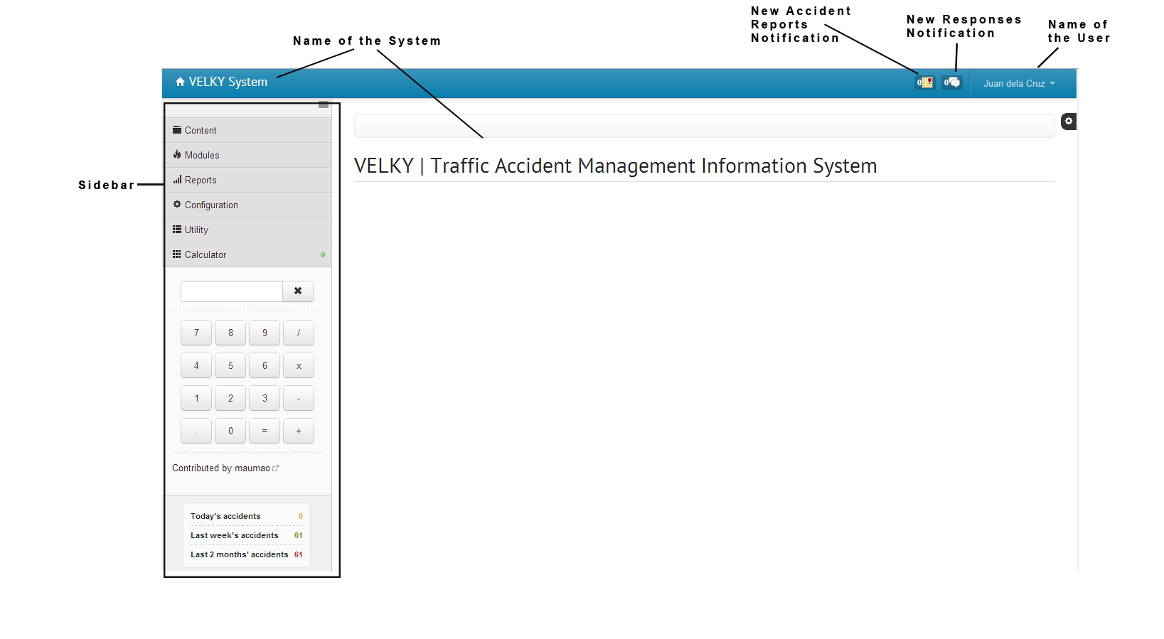

This screenshot shows the main interface of the system.